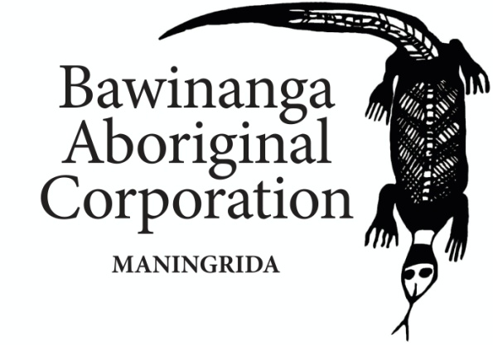

POSITION DESCRIPTION
POSITION TITLE: | Manager - Bawinanga Rangers
DIVISION / SECTION: | Bawinanga Rangers
SUPERVISOR: | Deputy Chief Executive Officer [DCEO]
CLASSIFICATION LEVEL: | 10
STATUS (FTE): | 1.0 FTE
NO. OF POSITIONS REPORTING DIRECTLY: |  | 4
NO. OF POSITIONS REPORTING INDIRECTLY: |  | 27

ABOUT BAWINANGA ABORIGINAL CORPORATION [BAC]:
BAC is a large and complex regional community development organisation providing services to homelands in the Maningrida region, administering some 50 grants and managing a suite of businesses and programs including: Housing, Civil Works, Essential Services, Women's Centre, BawinangaRangers, Barlmarrk Supermarket, Fuel Supplies, Mechanical Workshops, Arts and Culture/Djomi Museum, Community Patrol, Employment Services and Money Management Services.
BAC is governed by a Board of Directors who are elected by corporation members every two years. BAC enacts policies developed at the executive level through the leadership of the CEO and the Senior Management team.
BAC's mission is to improve the lifestyle of people on homelands by caring for country, preserving language and culture through the delivery of services to improve housing, health, education and roads.
BAC is a values based organisation with an emphasis on: Respect for Culture, Country and each other, Accountability, Teamwork, Continuous Improvement and Open and Honest Communication. These are principles and behaviours we display when working together.
PRIMARY RESPONSIBILITIES:
This position is responsible for Homelands Indigenous Protected Areas, Working on Country, Contracts and Wildlife teams within BAC. It operates under the direction of the Chief Executive Officer in accordance with BAC plans, policies, relevant legislation and funding requirements. Primary responsibilities include:

- Management and responsibility of the Djelk Ranger team consisting of 27 rangers and 4 Coordinators.
- Management and responsibility of the program finances and budgets.
- On behalf of the traditional owners and BAC members, actively manage the declared Indigenous Protected Areas by protecting its lands, sea, plants, animals and cultural sites.
- Take a lead role to reduce carbon emissions, control weeds, feral animals and wildfire, and carefully manage visitor impacts.
- Provide high level service delivery, advice and guidance on a full range of senior ranger activities including: environmental protection, biodiversity, conservation, national land care programs, immigration and border protection control, breaches by fishermen, the use of firearms, Aboriginal Land Rights and National Native Title requirements.
- Undertake high-level commercial and contract management with the Australian and Northern Territory Governments to ensure all primary contractual obligations are met and financial returns maximised.
- Have a hands-on project management approach to drive the implementation, monitoring and reporting of programs and projects within a complex range of work priorities.
- Foster strong partnerships and collaborations with local, Australian and NT government stakeholders to further reciprocal understanding and ensure legislative and regulatory compliance.
- Proactively manage, recognize, limit and report potential hazards when undertaking emergency response rescue and recovery and any high-risk responsibilities on the land and sea and cultural sites.
- Influence key stakeholders, participate and represent the interests of BAC at National Advisory Committees.
- Take a lead role in fostering and developing a work environment that is safe and continually improves its employment and professional development practices, policies and systems.
- Provide timely accurate advice, briefing papers and reports to the CEO as required.
SELECTION CRITERIA:
Essential:
- Demonstrated experience at a senior executive level working in a culturally inclusive workplace using the principles and practices of cultural competence and providing responsive services to an indigenous community;
- Demonstrated respect and understanding of cultural practices and indigenous rangers’ roles within their clan outside of the workplace and their cultural responsibility to country,
- Demonstrated ability to liaise with stakeholders and develop trusting strong relationships with Traditional Owners.
Prior experience managing and coordinating Aerial Prescribed Burning carbon programs, including the Savannah Burning methodology and managing fire fighting teams in remote areas with limited access and resources; able to produce flight lines and fire maps for APB with GIS software whilst understanding the nature of early dry season fires in northern Australia;
4. Knowledge and understanding of legislation/ regulation requirements for marine vessels operating in the marine
environment of Northern Australia.
5. Prior experience managing and creating new environmental projects such as large-scale feral animal control, fire
management, weed management; conservation areas.
6. The ability to coordinate and support multiple teams at once with each conducting different jobs/tasks and provide a
high level of logistical support to rangers on country and hold SAR responsibilities;
7. Experience in managing financesreporting on Grants and monitoring of budgets to comply with financial requirements.

Desirable:
- Have a Coxswain Certificate
- Experience living and working in remote communities.
- Experience and/or knowledge of Aboriginal culture and communities and how they operate.
- Experience working for a community development or not-for-profit organisation.

Approval:

Chief Executive Officer __________________________ _____________________
Signature Date

