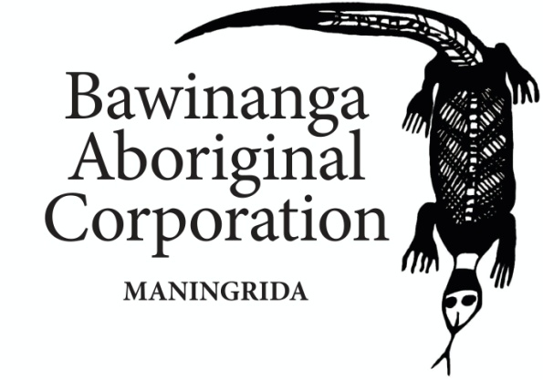
POSITION DESCRIPTION
POSITION TITLE: | Human Resources Management Manager
DIVISION / SECTION: | Corporate Services
SUPERVISOR: | Deputy Chief Executive Officer
CLASSIFICATION LEVEL: | 9.1
STATUS (FTE): | 1.0 FTE
LOCATION | Darwin Office
NO. OF POSITIONS REPORTING DIRECTLY: |  | 2 Employees based in Maningrida Office

POSITION RESPONSIBILITIES:

The Human Resources Management Manager is responsible for the management of the human resources unit in Bawinanga Aboriginal Corporation (BAC). It operates under the direction of the Chief Executive Officer in accordance with BAC plans, policies, relevant legislation and funding guidelines.

Key Duties:
- Develop a Human Resources Management Strategy for the corporation that is responsive to the needs of a workforce operating in a remote area.
- Review and update the corporation’s existing HR policies, procedures and systems to ensure they are in line with the Human Resources Management Strategy and the corporation’s strategic plan.
- Implement the strategies and actions from the Human Resources Management Strategy and review the strategy regularly to ensure that goals and objectives continue to be achieved.
- Drive and manage the Enterprise Bargaining Agreement process, completing all tasks associated with the Enterprise Agreement once lodged with the Fair Work Commission in 2023.
- Provide assistance and advice to managers about all staff management matters and current industrial relations.
- Attend to and manage staff disputes, conflicts and employee grievances in accordance with the corporation’s policies and procedures to ensure that the corporation deals with all matters appropriately.
- Prepare employment contracts for all new employees and in response to the requirements of the new Enterprise Agreement 2023.
- Assist Managers to conduct 6 monthly performance reviews of their staff and ensure that staff files are maintained correctly.
- Analyse and identify the training needs of the corporation’s workforce and develop an annual training plan to meet the mandatory training requirements of each sector.
- Provide timely advice to the senior management and the CEO to reduce the risk of noncompliance with the National Employment Standards, the Enterprise Agreement, corporation policies and procedures.

SELECTION CRITERIA:
Essential:
- Tertiary qualifications in Management - Human Resources Management
- Previous experience in a senior role within the field of Human Resources Management
- Previous experience working with a culturally diverse workforce
- Prior knowledge and experience of Enterprise Agreements and bargaining processes.
- Skilled in management of employee complaints and grievances
- Demonstrated ability to communicate effectively with senior management, employees and external entities.
- Eligible to apply for an NT Ochre Card
- A satisfactory National Police Check clearance

Desirable:
- Experience and/or knowledge of Aboriginal culture and communities and how they operate.
- Experience working for a community development or not-for-profit organisation.

Approval:

Chief Executive Officer ________________________________ ____________________
Signature Date

